VENUE NAME ________________________

VENUE CURATOR _Name /Phone_______________________

VENUE ARTIST’S INVENTORY FORM

Artist Name_________________________

Month/year _____________________________

Title | Medium | Size | Price | Picture | Buyer information  For office use only  Buyer Name/Address
Bay Reflections | Oil | 8x10 | $325 | 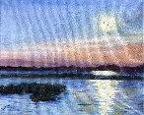 | Example

